**How well Argentine black and white tegus (*Salvator merianae*) are doing in South Florida and what factors are influencing it? A comparative analysis**

Jenna M. Cole1, Sergio A. Balaguera-Reina1, Melissa A. Miller1, Gabriela Cardozo2, Margarita Chiaraviglio2, Lee A. Fitzgerald3, Sergio Naretto2, and Frank J. Mazzotti1

1Department of Wildlife Ecology and Conservation, Fort Lauderdale Research and Education Center, University of Florida, Fort Lauderdale, 33314, USA

2Instituto de Diversidad y Ecología Animal (IDEA, CONICET and Universidad Nacional de Córdoba)

3Texas A&M University, College Station, TX

**Abstract**

Invasive species impose a major biological, ecological, and economic cost to ecosystems and countries where they are introduced and stablished. This is the case of Argentine black and white tegus (*Salvator merianae*), a South American lizard introduced to South Florida more than three decades ago. To manage tegus within their invasive range and curb their proliferation into new areas, management actions should be informed by first understanding tegu’s biology. Herein we estimated tegu body condition in native (Argentina) and non-native (South Florida, US) populations to determine how well this species is doing in a novel environment compared to its native range, and to identify what biological (percent of fat, size class), temporal (year, Julian day), and environmental (rainfall, temperature, habitat) factors influence tegu body condition in South Florida. On average, captured tegus in Argentina had larger fat reserves (mean percent of fat = 2.8 ± 2.3%) than tegus in South Florida (1.1 ± 1.4%). Nonetheless, females in both South Florida and Argentina had significantly larger fat reserves than males. Fulton’s K analysis showed that overall late juvenile-early adult tegus from South Florida had better body condition than tegus from this size class captured in Argentina. However, there were no differences in body condition in large adult tegus from the native and non-native range. Generalized additive mixed models showed very strong to moderate evidence of Julian day, minimum temperature, and percent of fat individually affecting tegu body condition in South Florida. The direction and magnitude of univariate effects varied from linear positive relationship (minimum temperature) impacting body condition up to 0.3 units to negative (Julian day) and positive (percent of fat) monomodal relationships impacting body condition up to 0.4 and 0.1 units, respectively.

**Keywords:** Body condition, Fulton’s K, invasive species, Argentina.

**Introduction**

The Argentine black and white tegu (hereafter tegu; *Salvator merianae*)is a large-bodied omnivorous lizard known to reach lengths up to 1.2 m and weigh up to 8 kg (Enge 2007, Lopes and Abe 1999). Tegus are native to South America (Brazil, Bolivia, Paraguay, Uruguay, and Argentina; Scott et al. 2016). Popular in the pet trade, tegus are found throughout Florida (United States; EDDMaps -<https://www.eddmaps.org/>) and have established populations within Hillsborough, Miami-Dade, Charlotte, and St. Lucie counties (Pernas et al, 2012, Harvey et al. 2021, Quin et al. 2022). Tegus are habitat generalists and occupy a variety of habitats including rainforest, coastal areas, savannahs, forest clearings, and disturbed areas (Enge 2007, Fitzgerald et al. 1991, Presch 1973). Due to their generalist behavior, vagility, and fecundity (Enge 2007), tegus have proven to be of concern to wildlife management agencies (Harvey et al. 2021). To manage tegus within their invasive range and to curb proliferation of tegus into new areas, management actions should be informed by an understanding of tegu biology.

An important question for invasive wildlife managers is how suitable is the available habitat for tegus in the non-native lands and how well are tegus coping with the new environmental conditions? Body condition has been used to assess habitat suitability and how well an individual is coping with its environment (Taylor et al 1979, Mazzotti et al. 2012) as well as to assess health, wellbeing, and energetic status of fish and wildlife (Nash et al. 2006, Stevenson and Woods 2006, Jakob et al. 1996, Hayes and Shonkwiler 2001). Body condition has been identified as relating to several aspects of fitness including reproductive success (Shine and Madsen 1997, Martín and López 2010), growth (Madsen and Shine 2002), survival (Civantos and Forsman 2000), predator-prey dynamics, habitat suitability (Amo et al. 2007), parasite load (Schall and Pearson 2000), probability of detection and capture (Tyrrell et al. 2009, Christy et al. 2010), and blood chemistry (Moore and Jessop 2003, McCallie and Klukowski 2022, Balaguera-Reina et al. 2022). Body condition can also influence behavior (Masson et al. 2016, Levine et al. 2021) – individuals in poorer body condition may engage in riskier foraging activity or movement patterns or be less likely to engage in dispersal than individuals who are in average, or above-average body condition (Gaines and McClenaghan 1980, Meylan et al. 2002, Schmitz 2017, Nafus et al. 2020). Conversely, dispersal rate may also increase in areas where resources are not available or where competition is high (Lutscher and Musgrave 2017).

Measuring energy stores (fat mass) is difficult and requires sacrificing the individual. Because of this, body condition is usually estimated as an index using morphological measurements of length and volume (usually mass) such as Fulton’s K (Nash 2006). Fulton’s K is a ratio index calculated by taking body mass (W) divided by body length (L) cubed **(**K=W/L3) and was first employed to assess body condition in fisheries science (Ricker 1975, Nash et al. 2006). Fulton’s K was identified as the best performing metric for tegus outperforming 10 other methods commonly used (McCaffrey et al. 2023).

To better organize conservation efforts and manage lands where invasive tegus occur, it is important to understand how this species is responding to the environment in non-native lands and identify factors that can contribute to the success and further establishment of tegu populations, allowing for better targeting of individuals for removal. In South Florida, individual tegus with higher body condition brumate earlier and longer than tegus in poorer body condition (Currylow et al. 2021); knowledge of these habits and the factors that influence tegu body condition can allow managers to better define an active season for trapping and removal of these individuals. It is also relevant to understand how well tegus are doing in the non-native lands comparing to populations from the native range as this can provide insights into how successful invaders tegus can be. However, there is a lack of knowledge regarding body condition in tegus across their native range.

The primary objective of this study was to estimate tegu body condition in native (Argentina) and non-native (South Florida, US) populations to determine how well this species is doing in a novel environment compared to its native range, and to identify what biological (percent of fat, size class), temporal (year, Julian day), and environmental (rainfall, temperature, habitat) factors influence tegu body condition in South Florida. We expect that 1) body condition of tegus from the native range is higher than in non-native lands as they are more adapted to latter environmental conditions, 2) body condition of tegus captured in South Florida are highest before brumation and lowest during summer reproduction as a result of reproductive and brumation activities, 3) females have higher body condition than males (as high levels of energy allocation are needed for reproductive purposes) and that adults have higher body condition than juveniles (larger animals allocate more energy towards weight rather than length), and 4) temporal variables (e.g., temperature, rainfall) rather than fix variables (e.g., habitat type) will have strong effects on tegu’s body condition as it regulate food availability and prey intake.

**Methods**

*Tegu data collection*

Tegus from their native range (Argentina, Cordoba province) derived from roadkill, hunted or captured alive from 2008 through 2012 (Figure 1). Tegus from their invasive range were captured in South Florida through removal efforts (live trapping) performed by the University of Florida, Florida Fish and Wildlife Conservation Commission (FWC), United States Geological Survey (USGS), and National Park Service (NPS). All tegu captured in South Florida came from the Miami-Dade County mostly from the Southern Glades Wildlife and Environmental Area (SGWEA) and in locations north, east, and west of it, including the Homestead Air Reserve Base, plant nurseries, agricultural lands, residential dwellings, and the surrounding areas of the C-111, C-111E, and Aerojet canals, South Dixie Highway, and Card Sound Road, from 2014 through 2019.

Tegus were humanely euthanized following AVMA standards (Underwood and Anthony 2020), and frozen until necropsy. Tegus were thawed prior to necropsy and examined for general health and condition by visually inspecting all internal organs and the body exterior for any abnormalities or deformities that may affect general health, body mass, body length, or fat mass. We measured on both native and non-native tegus total length (TL), snout-vent length (SVL), and total body mass using a flexible measuring tape and a spring scale. Coelomic wet-fat mass was obtained by removing and weighing discrete abdominal fat bodies to the nearest 0.0001 gr. Percent fat mass was calculated by dividing wet-fat mass by total body mass times 100.

***Figure 1.*** *Map depicting capture locations of tegus through their native (Argentina, Cordoba province) and non-native (South Florida) range. Captures coming from Florida are part of active trapping done to reduce the impact of this invasive species on Florida’s biodiversity. Captures from Argentina come from roadkill and animals hunted or trapped alive. Notice that not all records are included for Argentina as most of the data had not coordinates associate with.*

Tegus were assigned to one of three size-class groups based on snout-to-vent length (SVL) measurements: hatchlings and early juveniles with SVLs up to 20.2 cm, late juveniles to reproductive-sized adults with SVLs measuring 20.2–30.0 cm, and large adults SVL measuring 30.0 cm and greater. These groups were defined by looking for breakpoints across the relationship between mass and SVL based on linear regression models as described in McCaffrey et al. (2023).

*Body condition assessment*

Body condition for tegus in the native and non-native range was calculated and compared using Fulton’s K index and significance was evaluated at α = 0.05 for all statistical tests. Body condition outliers were removed using interquartile ranges -IQR (Tukey 1977) calculated in R version 4.3.1 (R core team, 2023) as well as tegus with physical abnormalities (missing limbs, regenerated tails, missing tails, and crooked spines) as these can influence Fulton’s K slope (McCaffrey et al. 2023). We tested the effect of variables such as sex, size group, and month on Fulton’s K values via Wilcoxon rank sum and Kruskal-Wallis tests. Dunn pairwise test using Bonferroni correction was used to define pairwise differences between size groups.

*Factors influencing body condition in the non-native range*

We assessed the effect of physiological (percent of fat), temporal (year, Julian day), environmental (mean rainfall and temperature and monthly minimum maximum temperature), and habitat type (prairies and bog, marshes, freshwater forested wetlands, or urban) variables on tegu’s body condition in South Florida via generalized additive mixed models (GAMM) for very large datasets (*bam* function) from the “mgcv” package (Wood, 2011). Temporal variables were obtained from capture date. Mean monthly weather data were gathered from the Florida Automated Weather Network (FAWN, <https://fawn.ifas.ufl.edu/>) Homestead station. Habitat type was determined for each tegu’s capture location using the Florida Cooperative Land Cover Map (CLC), Version 3.5 (Kawula and Redner 2018). We modified CLC to better describe the habitat where tegus were captured by removing polygons labeled as canal, transport, and vegetative berm and replacing them with the adjacent habitat, which more appropriately described the area where captures occurred. CLC polygons were rasterized to 1 m x 1 m pixels via polygon to raster tool in ArcGIS pro 3.2.1 (ESRI 2024), clipped, and values were extracted to the capture locations of each tegu. Once assigned, habitat was then categorized based on the CLC classification system (Kawula and Redner 2018).

Selection of covariates and determination of their importance by groups was done using a wrapper method (random forest classification algorithm) for both individual and mean datasets via the Boruta package (Kursa and Rudnicki, 2010). Algorithm was trained 1,000 times and variable importance was defined based on the mean decrease accuracy. Only variables with a Z-score higher than the shadow (shuffled) variables were selected as relevant. Once relevant variables for allometric elevation were defined, we parametrized GAMM models using Fulton’s K as a response variable, habitat type as a parametric term, all covariates as univariate thin plates splines (‘tp’), the most relevant variable selected plus all other covariates as bivariate tensor interactions (‘ti’), all variables interacting with year as a factor smooth (‘fs’), size class as a random effect.

We tested the best distribution to fit our model (gaussian response - identity link and gamma response - log link) via QQ and residual plots (*gam.check* function) to see whether models followed selected theoretical distributions (Wood, 2017). We used the default basis complexity (k) for all models and checked whether this value was enough for each parameter via the *gam.check* function. Models were ran using the fast restricted maximum likelihood (fREML) and the double penalty approach was selected (select = TRUE) allowing us to penalize the null space without dropping any covariate within post processing (Marra and Wood, 2011). Finally, we selected the best model based on the Akaike Information Criteria (AIC; the lowest value) via the *aic* function and the analysis of deviance (*anova* function) for *gam*. Models were plotted using the *draw* function from the “Gratia” package (Simpson, 2024).

**Results**

We captured and processed a total of 1,634 tegus from South Florida (748 female, 886 male) and 628 tegus from Argentina (265 females, 363 males; Table 1). Most tegus captured in South Florida were hatchlings-early juveniles and late juvenile-early adults (90.9%) whereas most of the tegus captured in Argentina were large adults (97%). On average, captured tegus in Argentina had larger fat reserves (mean percent of fat = 2.8 ± 2.3%) than tegus in South Florida (1.1 ± 1.4%). However, when compared by month we found no significant differences in fat reserves between tegus captured in Argentina and South Florida in February (p-value = 0.35), marginal differences in tegus captured in March (p-value = 0.06), and high significant differences of fat reserves in tegus captured in September (p-value = 0.004) and October (p-value = 0.003). We only used these months for comparison as they were the only ones where captures overlapped (Figure 2).

***Table 1.*** *Morphometric data collected from Argentine and black tegus captured across their native (Argentina -Arg; 2008-2012) and invasive (South Florida -SF; 2014-2019) range grouped by meaningful size groups (HE = hatchling-early juveniles, LJA = late juveniles to reproductive-sized adults, LA = large adult) as defined by McCaffrey et al. (2023). Gr = Size group, Ar = area, N = total tegus measured, F = female, M = male, SVL = mean snout-vent length, W = mean weight, FK = mean Fulton’s K, MCFW = mean celomic fat weight, MPF = mean percent fat, n nec = total tegus necropsied, and fat measurements taken. Values are expressed as mean ± standard deviation.*

|  |  |  |  |  |  |  |  |  |  |  |
| --- | --- | --- | --- | --- | --- | --- | --- | --- | --- | --- |
| **Gr** | **Ar** | **N** | **F** | **M** | **SVL (cm)** | **W (g)** | **MFK** | **MCFW (g)** | **MPF (%)** | **N nec** |
| HE | SF | 403 | 208 | 195 | 17.0 ± 2.4 | 153 ± 62.2 | 2.9 ± 0.3 | 1.6 ± 2.7 | 0.9 ± 1.3 | 151 |
| Arg | 2 | 0 | 2 | 19.5 ± 0.7 | 200 ± 14.1 | 2.7 ± 0.1 |  |  | 0 |
| LJA | SF | 1081 | 468 | 613 | 24.8 ± 2.6 | 488 ± 167 | 3.1 ± 0.3 | 5.9 ± 8.8 | 1.1 ± 1.4 | 453 |
| Arg | 17 | 5 | 12 | 28 ± 1.6 | 647 ± 129 | 2.9 ± 0.4 | 7.2 ± 5.9 | 1.0 ± 0.8 | 12 |
| LA | SF | 150 | 75 | 78 | 33.4 ± 2.9 | 1,228 ± 360 | 3.2 ± 0.3 | 22 ± 23.8 | 1.8 ± 1.6 | 63 |
| Arg | 609 | 260 | 349 | 38.5 ± 3.5 | 1,872 ± 599 | 3.2 ± 0.4 | 56.0 ± 50.2 | 2.9 ± 2.3 | 547 |
| All | SF | 1634 | 748 | 886 | 23.7 ± 5.2 | 473.4 ± 330.2 | 3.1 ± 0.3 | 6.5 ± 11.7 | 1.1 ± 1.4 | 667 |
| Arg | 628 | 265 | 363 | 38.2 ± 4 | 1,833.3 ± 639.4 | 3.2 ± 0.4 | 54.9 ± 50.1 | 2.8 ± 2.3 | 559 |

Morphological traits (SVL and weight) did not significantly vary between sexes in tegus captured in South Florida (SVL p-value = 0.36 total weight p-value = 0.28) but it did in Argentina (p-value = 0.000), having larger and heavier males (38.7 ± 4.4 cm SVL and 1,928.5 ± 694.3 g) than females (37.4 ± 3.1 cm SVL and 1,702.8 ± 500.4 g). Nonetheless, females in both South Florida (1.3 ± 1.3%) and Argentina (4.1 ± 2.6%) had significantly larger fat reserves (p-value = 0.000) than males (1.1 ± 1.5% and 2.1 ± 1.7%, respectively).

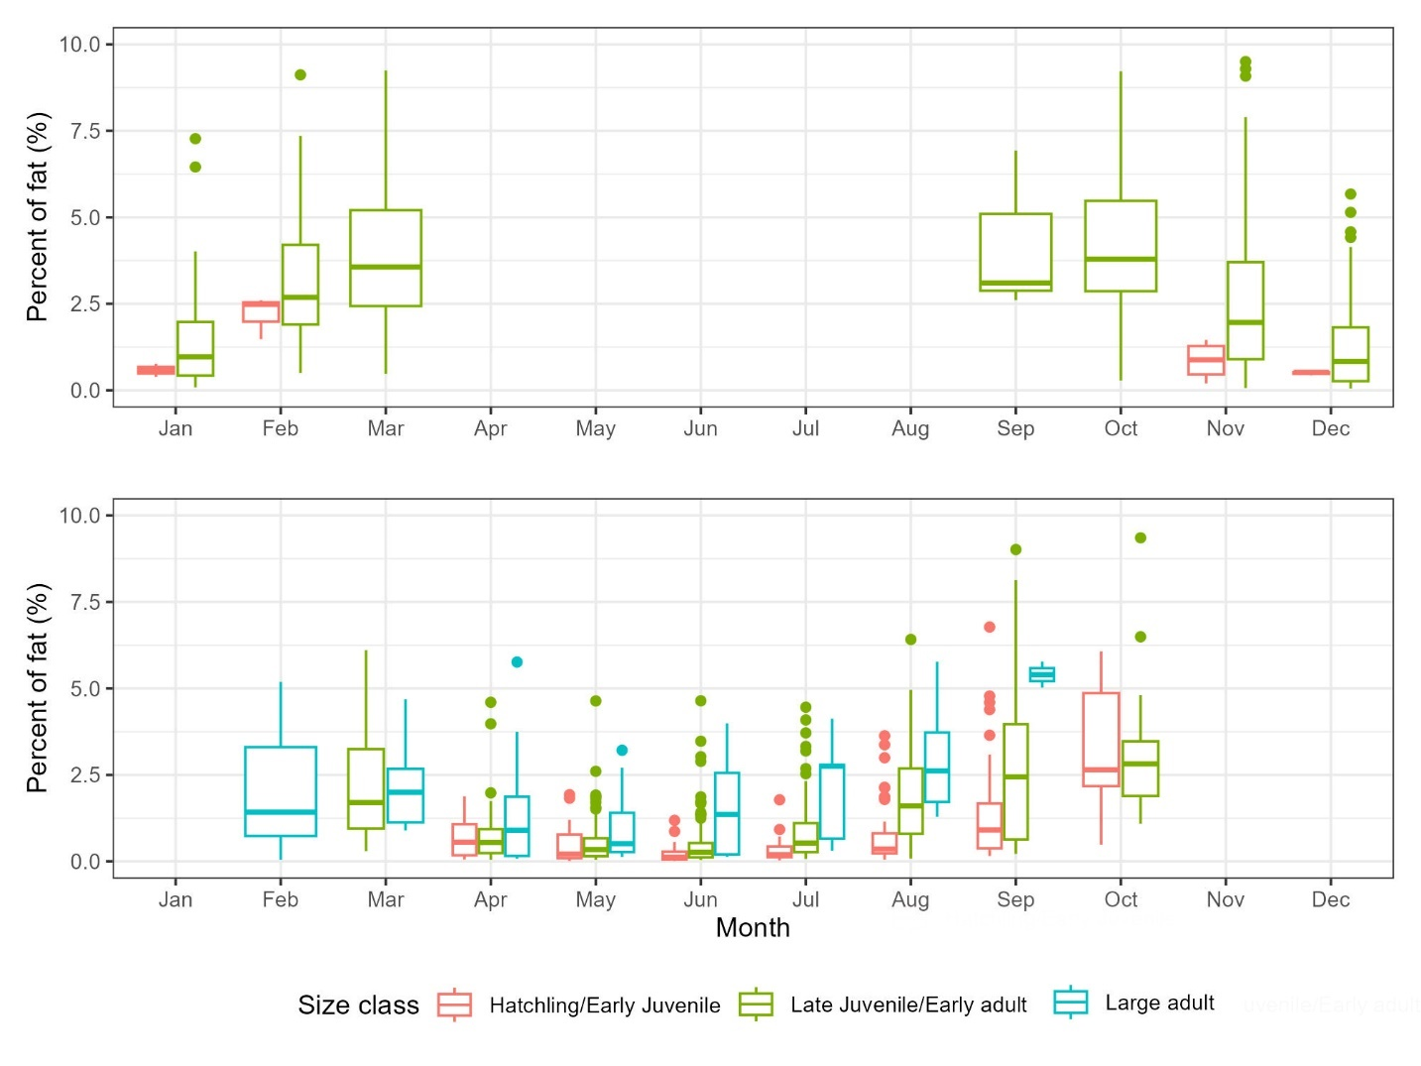

***Figure 2.*** *Percentage of fat on Argentine and black tegus captured in the native (Argentina) and non-native (South Florida) range by month. Notice that although there were not large adults necropsied in Argentina, the fat reserves of late juveniles-early adults were overall larger than in South Florida.*

Fulton’s K analysis showed that overall late juvenile-early adult tegus from South Florida had better body condition than tegus from this size class captured in Argentina with a significant marginal difference (p-value = 0.05), However, there were no differences in body condition in large adult tegus from the native and non-native range (p-value = 0.2). Overall, smaller tegus had lower body condition compared to larger tegus in both native and non-native range ranging from 2.9 to 3.2 in South Florida and 2.7 to 3.2 in Argentina (Table 1). We found no significant differences in body condition of tegus captured in Argentina and South Florida by month specifically in February (p-value = 0.3), March (p-value = 0.8), September (p-value = 0.4), and October (p-value = 0.1) as these were the only months when captures overlapped (Figure 3).

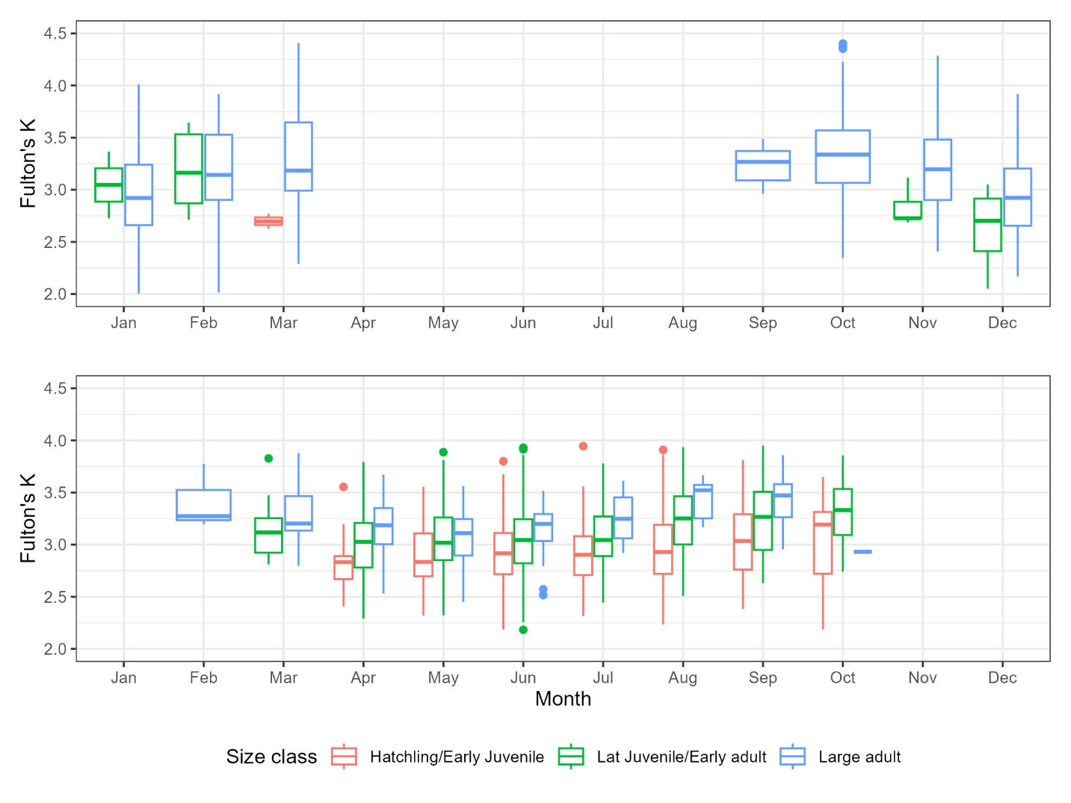

***Figure 3.*** *Fulton’s K on Argentine and black tegus captured in the native (Argentina) and non-native (South Florida) range by month. Note that although most of the median Fulton’s K in both Argentina and South Florida is between 3.0 and 3.5, tegus in the native range can get much higher scores than in the non-native range, showing that although tegus in South Florida are not having a bad time, they still do not reach the maximum values from the native range.*

*Factors influencing body condition in the non-native range*

Variable selection analysis showed that most of the variables were important (performed better than random) for body condition (Fulton’s K) except for Habitat type and sex (Z-score = -0.29 and -0.05, respectively). The most important variable was percent of fat (Z-score = 42.6) followed by Julian day (Z-score = 11.5), minimum and maximum temperature (Z-score = 7.9 and 6.9), year (Z-score = 6.7), mean temperature and rainfall (Z-score = 6.5, each).

Generalized additive mixed models (Gaussian distribution identity link, deviance explained by the model 37.3%) showed very strong to moderate evidence of Julian day, minimum temperature, and percent of fat individually affecting tegu body condition in South Florida (Figure 4). The direction and magnitude of univariate effects varied from linear positive relationship (minimum temperature) impacting body condition up to 0.3 units to negative (Julian day) and positive (percent of fat) monomodal relationships impacting body condition up to 0.4 and 0.1 units, respectively. However, when factored by year other variables such as rainfall (mainly in 2015 and 2018), mean temperature (mainly in 2015 and 2016), and maximum temperature (mainly in 2015) had also an effect on tegu’s body condition. From those, mean temperature had the largest impact on tegu body condition dropping values up to 0.3 units when increase from 20 to 26° C in 2015.

Bivariate interactions showed only rainfall weakly affecting body condition when combined with the percent of fat with high rainfall values (around 30 cm monthly) and percent of fat values around 5% providing an increase in body condition values of up to 0.04 units. Finally, all habitat types showed strong positive linear effect on tegu body condition having an impact of body condition up to 0.3 units except of fresh forested wetland where we got an impact of 0.

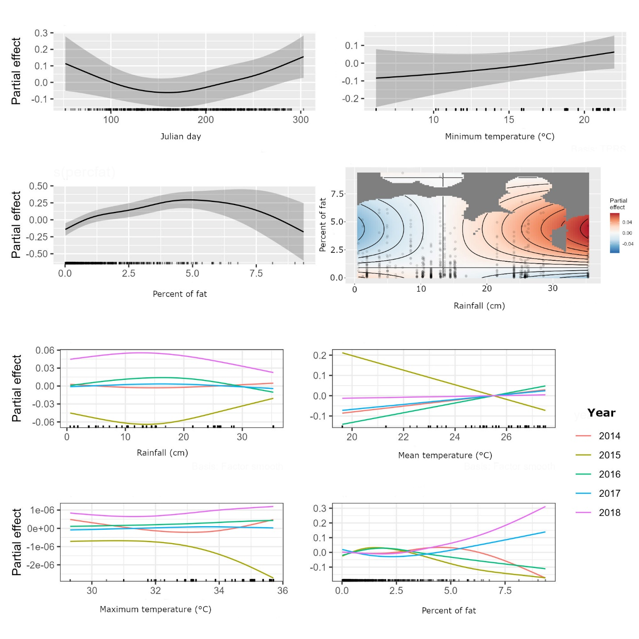

***Figure 4.*** *Univariate and bivariate partial effects (all predictors are kept fixed at the mean value except for the variable of interest) of predictors that showed at least weak evidence of an effect on Argentine and black tegu body condition in South Florida. Notice how variables such Julian day and percent of fat has the largest impact (change in magnitude) in body condition and predictors such as Maximum temperature the lowest.*

**Discussion**

Fulton’s K Analysis

We investigated tegu body condition, and how selected variables influenced the variation of body condition. Although the slope assumption of Fulton's index was violated (slope = 3.0), the slope values for each size group were close to 3.0, and overlapped with this value for hatchlings and early juveniles (slope = 3.04 ± 0.04), and large adults (slope = 2.96 ± 0.09). Large juvenile and reproductive adult tegus did not overlap with 3.0 but were very close with a slope of 3.08 ± 0.03. The mean SVL of these groups is not the same which can also lead to size biasing of Fulton’s K Other statistical assumptions including normality and homoscedasticity were also violated. Future research focusing on the effects of these violations on comparisons should be done to understand how flexible those could be.

Body condition was similar between male and female tegus across all groups, likely due to Fulton’s Index being calculated using mass and length which were not significantly different between male and female tegus (Table 3). Females were seen to have larger fat mass and higher percentages of fat than males, which likely reflects reproductive requirements and the importance of fat reserves for egg production. Lower levels of fat observed in male tegus may indicate a contribution of other tissues (e.g. muscle) to male body condition. Tegus were of highest body condition just before brumation and also had highest fat mass and percent fat during this period of time as well. Fat mass, percent fat, and body condition were highest just before tegu brumation (September and October captures), except for in large adult tegus where body condition was equivalent to tegus captured just after emergence in February. For hatchlings and early juveniles fat mass, percent fat, and body condition were lowest in June when new hatchlings were just emerging from nests, and in late juveniles, reproductive adults, and large adults these metrics were lowest in May-June during peak reproductive activity.

Currylow et al. (2021) demonstrated that tegus with higher body condition brumated sooner, for longer periods of time, and maintained higher fat store than tegus with lower body condition scores in South Florida. Similarly, Fitzgerald et al. (1999) reported that larger individuals disappeared from trap arrays during cooler months, meanwhile smaller individuals remained active during those months across the native range. This appears similar to our findings, with large adult tegus disappearing from traps after September and maintaining higher percentages of fat stores than smaller tegus (Figure 3). Brumation length was similar amongst size classes, except for hatchling and early juvenile tegus which remain in brumation for approximately one month longer than larger tegus. Lizard body size has previously been linked to activity patterns and habitat selection (Asplund 1974, Fitzgerald et al. 1999). In their native range tegu activity is influenced by seasonal changes in temperature, a characteristic that is not as strong in South Florida. It is possible that time of brumation is related to photoperiod or metabolic capabilities, rather than temperature. Identifying trends in behavior and activity can assist in targeting reproductively active individuals for removal.

Variables Influencing Body Condition

Our results suggest variables that influence tegu body condition may vary depending upon reproductive status and movement behaviors. It is possible that other variables also are influential on body condition of tegus in this group such as metabolism, resource availability, size of established home range, movement, and reproductive efforts. Lizard body size has been related to movement (Asplund 1974) so it is possible that variables related to resource availability and movement may be most influential to Juvenile-large adult tegu body condition, which was mostly explained by temporal and environmental variables.

Our best model including all variables explained up to 15% of the variation found in body condition of juvenile and reproductive adult tegus, and 7% of the variation found in body condition of large adult tegus (Table 2-7). For late juveniles and reproductive adults, as the distance from the US-1/424th street underpass (UP) increased, body condition also increased which may be an impact of lower competition considering that distance from UP has been found to be negatively correlated with trap success (Cole et al. 2020), or access to better resources. The months May, June, and July correlate with the time frame when reproductively active tegus are finishing up breeding season and likely laying nests (May; Meshaka et al. 2019, Pernas et al. 2012), followed by a period of foraging to replenish fat stores prior to brumation.

It is possible that variables not considered in this study such as width of dry habitat along canals and distance from canal may increase performance of the models. For tegus trapped in 2019, distance from canal and habitat width were shown to have a positive impact on capture per unit effort (CPUE), while distance from US-1 (distance from UP in this study) and distance from building (distance from JDC in this study) were seen to have a negative impact on CPUE (Cole et al. 2020). This study did not consider habitat width or distance from canal as possible predictor variables, which may provide further explanation of tegu body condition.

Tegus included in this study were not trapped randomly. Trap locations were selected and clustered based on trap performance, with more traps placed in locations where trap success was higher. Trapping of tegus may target individuals within the tegu population that are displaying riskier foraging behavior, possibly related to lower fitness (Tyrrell et al. 2009, Christy et al. 2010, Goossens et al. 2020). Studies of foraging behavior in brown tree snakes and mammals have reported individuals with lower body condition, or those who may be experiencing pressure due to lack of resources, may be more inclined to engage in riskier foraging behavior (Tyrrell et al. 2009, Christy et al. 2010). This does not appear to be the case for tegus included in this study, which seem to be of a uniformly healthy body condition with Fulton’s K values ranging from 2.18 – 3.95 with a mean of 3.06 ± 0.33. For instance, nine tegus trapped had Fulton’s K values of 3.9, 2 standard deviations above the mean Fulton’s value for large adult tegus and at the higher end of overall Fulton’s values for this population. It appears that tegus are entering traps despite appearing to be of healthy body condition.

It is possible that other measures, such as scaled fat or residual fat, to quantify actual body condition may be more appropriate to reduce association with body length (Falk et al. 2017). Other factors to be considered are that celomic body fat stores may not be representative of total fat stores. Fat stores, particularly celomic fat stores, are depleted heavily as eggs are formed in female tegus (Meshaka et al. 2019). Body fat can be stored elsewhere including in muscle, liver and tail (Price 2017, Souza et al. 2004). We did not investigate the contribution of muscle, water, or other sources of matter to overall tegu body condition. The contribution of other tissue to body condition can be seen when comparing native and Florida tegu body condition relative to measure of actual fat and percent fat. The body condition of Florida tegus was found to be just as good as tegus captured in the native range, however, native tegus were shown to be larger, heavier, and fatter (Table 2-5). Other tissue and fat stores may contribute more to Florida tegu body condition than in native tegus, and that the same is true when comparing the body condition of male and female tegus in the Florida population. Future research should address the contribution of other fat stores and sources of body mass including contribution of reproductive cycle and stomach content to tegu body condition, as well as other measure of true body condition including residual fat, scaled fat, and dried fat weights.

Tegus are a successful invasive species, particularly in South Florida, and populations exist throughout the state and in other southern states. Tegus do not face harsh winters or extreme weather in South Florida compared to those witnessed in more northern counties and states. The body condition of tegus in South Florida may provide an indication of what “ideal” invasive tegu body condition looks like in optimal conditions. I would expect tegu body condition to decrease as tegus face cooler temperatures and drier environments. Body condition relates to reproductive success and dispersal, which can be relevant when assessing invasions in other parts of the state and country. Future research on the body condition of tegus should be considered to provide further insight and understanding of how tegus are responding physically to varying habitats, season, and environmental differences throughout their invasive and native range.

**Acknowledgements**

**Literature Cited**

Amo, L., López, P., & Martín, J. (2007) Habitat deterioration affects body condition of lizards: A behavioral approach with Iberolacerta cyreni lizards inhabiting ski resorts. Biological Conservation, 135(1), 77-85. https://doi.org/10.1016/J.BIOCON.2006.09.020

Anderson, G. B., Bell, M. L., & Peng, R. D. (2013) Methods to calculate the heat index as an exposure metric in environmental health research. Environmental health perspectives, 121(10), 1111-1119

Asplund, K.K., 1974. Body size and habitat utilization in whiptail lizards (Cnemidophorus). *Copeia*, pp.695-703.

Bolger, T., & Connolly, P. L. (1989). The selection of suitable indices for the measurement and analysis of fish condition. Journal of Fish Biology, 34(2), 171-182.

Christy, M. T., Yackel Adams, A. A., Rodda, G. H., Savidge, J. A., & Tyrrell, C. L. (2010). Modelling detection probabilities to evaluate management and control tools for an invasive species. *Journal of Applied Ecology*, *47*(1), 106-113.

Christy, M.T., Savidge, J.A., Adams, A.Y., Gragg, J.E. and Rodda, G.H., 2017. Experimental landscape reduction of wild rodents increases movements in the invasive brown treesnake (Boiga irregularis). *Management of Biological Invasions*, *8*(4), pp.455-467.

Civantos, E., & Forsman, A. (2000) Determinants of survival in juvenile Psammodromus algirus. Oecologia, 124(1), 64-72. https://doi.org/10.1007/S004420050025

Cole, J., Klovanish, C., Butler, Z., Miller, M. A., & Mazzotti, F. J. (2020) Removal of Argentine Black and White Tegus in Southern Miami-Dade County. 2020 Final Report to the Florida Fish and Wildlife Conservation Commission

Currylow, A. F., Collier, M. A. M., Hanslowe, E. B., Falk, B. G., Cade, B. S., Moy, S. E., . . . Yackel Adams, A. A. (2021) Thermal stability of an adaptable, invasive ectotherm: Argentine giant tegus in the Greater Everglades ecosystem, USA. Ecosphere, 12(9)

Enge, K. M. (2007) FWC bioprofile for the Argentine Black and White Tegu (Tupinambis merianae). Florida Fish and Wildlife Conservation Commission report, Tallahassee, FL.

Falk, B. G., Snow, R. W., & Reed, R. N. (2017) A validation of 11 body-condition indices in a giant snake species that exhibits positive allometry. PLOS ONE, 12(7), e0180791-e0180791

Fitzgerald, L. A., Chani, J. M., & Donadio, O. E. (1991) Tupinambis lizards in Argentina: Implementing management of a traditionally exploited resource. In J. Robinson & K. Redfors (Eds.), Neotropical wildlife use and conservation (pp. 303-316). University of Chicago Press

Fitzgerald, L. A., Cruz, F. B., & Perotti, G. (1999). Phenology of a lizard assemblage in the dry Chaco of Argentina. *Journal of Herpetology*, 526-535.

Gaines, M. S., & McClenaghan, L. R. Dispersal in Small Mammals. Ann. Rev. EcoL Syst, 1, 163-196

Goossens, S., Wybouw, N., Van Leeuwen, T., & Bonte, D. (2020) The physiology of movement. Movement Ecology 2020 8:1, 8(1), 1-13

Grolemund, G., & Wickham, H. (2011) Dates and Times Made Easy with lubridate. Journal of Statistical Software, 40(3), 1-25

Harvey, R. G., Dalaba, J., Ketterlin, J., Roybal, A., Quinn, D., & Mazzotti, F. J. (2021) Growth and Spread of the Argentine Black and White Tegu in Florida. EDIS, 2021(5)

Hayes, J. P., & Shonkwiler, J. S. (2001). Morphometric indicators of body condition: worthwhile or wishful think. *Body Composition Analysis of Animals: A Handbook of Non-Destructive Methods, Cambridge University Press, Cambridge*, 8-38.

Jakob, E. M., Marshall, S. D., & Uetz, G. W. (1996) Estimating Fitness: A Comparison of Body Condition Indices. Oikos, 77(1), 61-61

Kassambara, A., 2018. ggpubr:'ggplot2'based publication ready plots. *R package version*, p.2.

Kawula, R., & Redner, J. (2018) Florida Land Cover Classification System. Florida Fish and Wildlife Conservation Commission. Tallahasee, Fl.

Labocha, M. K., & Hayes, J. P. (2012) Morphometric indices of body condition in birds: A review. Journal of Ornithology, 153(1), 1-22

Le Cren, E. D. (1951). The length-weight relationship and seasonal cycle in gonad weight and condition in the perch (Perca fluviatilis). The Journal of Animal Ecology, 201-219.

Levine, B. A., Douglas, M. R., Adams, A. A. Y., Lardner, B., Reed, R. N., Savidge, J. A., & Douglas, M. E. (2021) Trait heritability and its implications for the management of an invasive vertebrate. Biological Invasions, 23(11), 3447-3456

Lopes, H.R., and A.S. Abe. (1999) Biologia reprodutivo e comportamento do teiú, Tupinambis merianae, em cativeiro (Reptilia, Teiidae). Pages 259–272 in T. G. Fang, O. L. Montenegro, and R. E. Bdmer, editors. Manejo y Conservación de Fauna Silvestre en América Latina. Instituto de Ecología, La Paz, Bolivia

Lüdecke, D., Ben-Shachar, M. S., Patil, I., Waggoner, P., & Makowski, D. (2021) performance: An R Package for Assessment, Comparison and Testing of Statistical Models. Journal of Open Source Software, 6(60), 3139-3139.

Lutscher, F., & Musgrave, J. A. (2017) Behavioral responses to resource heterogeneity can accelerate biological invasions. Ecology, 98(5), 1229-1238

Madsen, T., & Shine, R. (2002) Short and chubby or long and slim? Food intake, growth and body condition in free-ranging pythons. Austral Ecology, 27(6), 672-

Martin, J., & Lopez, P. (2010). Condition-dependent pheromone signaling by male rock lizards: more oily scents are more attractive. *Chemical senses*, *35*(4), 253-262.

Masson, L., Brownscombe, J. W., & Fox, M. G. (2016) Fine scale spatio-temporal life history shifts in an invasive species at its expansion front. Biological Invasions, 18(3), 775-792

Mazzotti, F.J., Cherkiss, M.S., Brandt, L.A., Fujisaki, I., Hart, K., Jeffery, B., McMurry, S.T., Platt, S.G., Rainwater, T.R. and Vinci, J., 2012. Body condition of Morelet's crocodiles (Crocodylus moreletii) from Northern Belizea. *Journal of Herpetology*, *46*(3), pp.356-362.

McCaffrey, K.R., Balaguera-Reina, S.A., Falk, B.G., Gati, E.V., Cole, J.M. and Mazzotti, F.J., 2023. How to estimate body condition in large lizards? Argentine black and white tegu (Salvator merianae, Duméril and Bibron, 1839) as a case study. *Plos one*, *18*(2), p.e0282093.

McCallie, K. L., & Klukowski, M. (2022). Corticosterone in three species of free-ranging watersnakes: Testing for reproductive suppression and an association with body condition. *Comparative Biochemistry and Physiology Part A: Molecular & Integrative Physiology*, *269*, 111214.

Meshaka, W. E., Mazzotti, F. J., & Rochford, M. R. (2019) Ecological Plasticity and the Future of the Argentine Giant Tegu (Salvator merianae Dumeril and Bibron, 1839) in the Southeastern US, 18(4), 659-676

Meylan, S., Belliure, J., Clobert, J., & De Fraipont, M. (2002) Stress and Body Condition as Prenatal and Postnatal Determinants of Dispersal in the Common Lizard (Lacerta vivipara) Hormones and Behavior, 42(3), 319-326

Miller, J. L. l., & Erickson, M. L. (1974) On dummy variable regression analysis: A Description and Illustration of the Method. Sociological Methods & Research, 2(4), 409-430

Moore, I. T., & Jessop, T. S. (2003). Stress, reproduction, and adrenocortical modulation in amphibians and reptiles. Hormones and Behavior, 43(1), 39-47.

Nafus, M. G., Yackel Adams, A. A., Boback, S. M., Siers, S. R., & Reed, R. N. (2020) Behavior, size, and body condition predict susceptibility to management and reflect post-treatment frequency shifts in an invasive snake. Global Ecology and Conservation, 21, e00834-e00834

Nash, R. D., Valencia, A. H., & Geffen, A. J. (2006). The origin of Fulton’s condition factor—setting the record straight. Fisheries, 31(5), 236-238.

Ogle, D.H., Doll, J.C., Wheeler, P. and Dinno, A., 2021. FSA: fisheries stock analysis. R package version 0.9. 1. *Vienna: R Core team*.

Pernas, T., Giardina, D.J., McKinley, A., Parns, A. and Mazzotti, F.J., 2012. First observations of nesting by the Argentine black and white tegu, Tupinambis merianae, in south Florida. *Southeastern Naturalist*, *11*(4), pp.765-770.

Presch, W. (1973) A review of the tegus, lizard genus Tupinambis (Sauria: Teiidae) from South America. Copeia, 740-746

Quinn, D. P., Dallas, T. R., Cunningham, C. C., Hamilton, A. S., & Funck, S. A. (2022). An incipient population of Argentine black and white tegus (Salvator merianae) in Charlotte County, Florida, USA. *Herpetological Conservation and Biology*, *17*(3), 539-547.

Ricker, W. E. (1975). Computation and interpretation of biological statistics of fish populations. Bull. Fish. Res. Bd. Can., 191, 1-382.

Schall, J. J., & Pearson, A. R. (2000) Body condition of a Puerto Rican anole, Anolis gundlachi: Effect of a malaria parasite and weather variation. Journal of Herpetology, 34(3), 489-491

Schmitz, O. (2017) Predator and prey functional traits: understanding the adaptive machinery driving predator–prey interactions. F1000Research, 6, 1767-1767.

Scott, N., Pelegrin, N., Montero, R., Kacoliris, F., Fitzgerald, L., Carreira, S., Cacciali, P., Moravec, J., Cisneros-Heredia, D.F., Aparicio, J. & Avila-Pires, T.C.S. 2016. *Salvator merianae*. *The IUCN Red List of Threatened Species* 2016: e.T178340A61322552. <https://dx.doi.org/10.2305/IUCN.UK.2016-1.RLTS.T178340A61322552.en>. Accessed on 04 October 2024.

Shine, R., & Madsen, T. (1997). Prey abundance and predator reproduction: rats and pythons on a tropical Australian floodplain. Ecology, 78(4), 1078-1086.

Stevenson, R. D., & Woods Jr, W. A. (2006). Condition indices for conservation: new uses for evolving tools. Integrative and comparative biology, 46(6), 1169-1190.

Taylor, J.A., 1979. The foods and feeding habits of subadult Crocodylus porosus Schneider in northern Australia. *Wildlife Research*, *6*(3), pp.347-359.

Tukey, J. W. (1977) Exploratory data analysis (Vol. 2, pp. 131-160)

Tyrrell, C. L., Christy, M. T., Rodda, G. H., Adams, A. A. Y., Ellingson, A. R., Savidge, J. A., Bischof, R. (2009) Evaluation of trap capture in a geographically closed population of brown treesnakes on Guam. Journal of Applied Ecology, 46, 128-135.

Underwood, W. and Anthony, R., 2020. AVMA guidelines for the euthanasia of animals: 2020 edition. *Retrieved on March*, *2013*(30), pp.2020-1.

Venables, W. N., & Ripley, B. D. (2002) Modern Applied Statistics with S (4 ed.). Springer

Wickham, H. (2016) ggplot2: Elegant Graphics for Data Analysis. Springer

Wickham, H., François, R., Henry, L. and Müller, K., 2021. RStudio (2015) dplyr: a grammar of data manipulation. *R package version 0.4*, *3*, p.156.